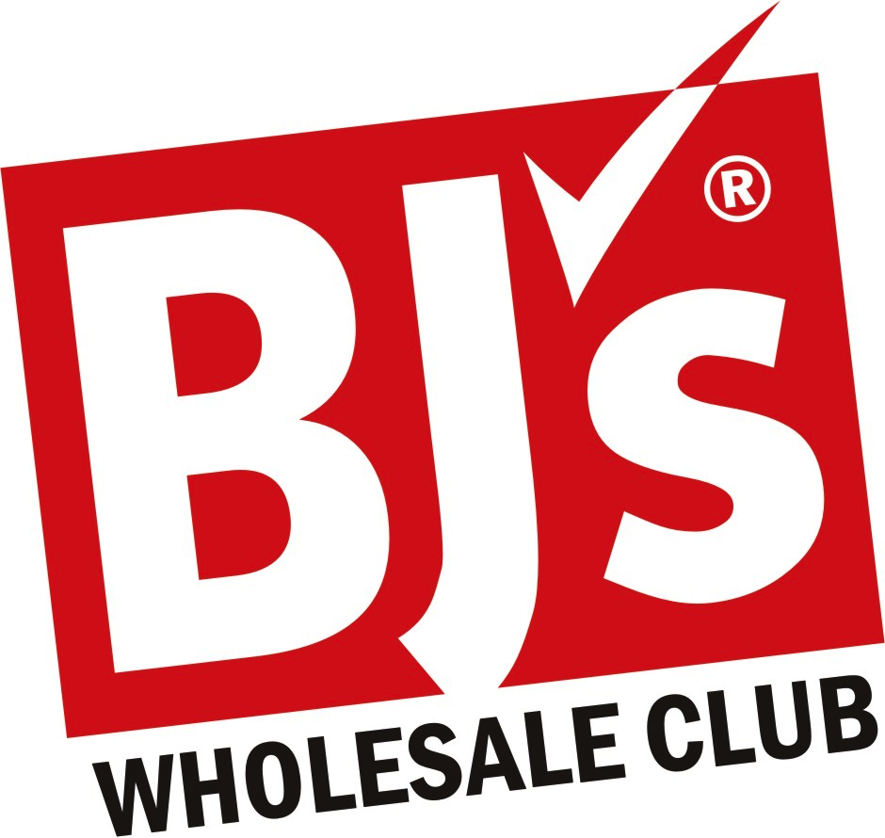

FOR ALL EMPLOYEES, FAMILY AND FRIENDS

(Special 2020 Offer Is “NOT AVAILABLE” In-Club Or At BJs.com)

OFFER IS SUBJECT TO CHANGE

“Renewing Members” must call me for qualifications

RECEIVE YOUR MEMBERSHIP CARDS IN AS LITTLE AS ONE WEEK

“12 Months” Only $25 (reg $55 for 12 months)
Get 2 Membership Cards For The Price of One

*****Membership Is Good At All BJ’s Club Locations*****
We Accept All Manufacturers’ Coupons Together With Ours

- Smaller Portions of Organic Fruits / Veggies and 25% Off Grocery Store Prices
- BJ’s Has More Name Brand Products Than Our Competitors
- We Have A Butcher On Staff For Customized Needs
- We Have Name Brand Lunch Meat and Cheese Deli, Order a Little Or A lot
- Super Savings On: Prescription Glasses/Contacts, Hotel Vacation Packages & Cruises
- 100% Money-Back Guarantee On Membership Fee Anytime Before Expiration

For Membership Call Teresa Yosick @ 330-447-9717
Or Mail This App To: BJ’s Wholesale Club, Attention: Teresa Yosick
6924 Frank Ave NW North Canton, OH 44720 Email: tyosick@bjs.com
Visit www.bjs.com For All Locations

Check One______The Standard Membership $25 (Reg. $55)
______The Rewards Membership $50 (Reg. $110) Receive 2% Payback

Company:___________________________________POSITION:________________________

Name: _______________________________________________Phone:__________________

Home Address: _______________________________City: __________________St____Zip:______

Email:________________________________________________________________________

Free Card Name: ________________________________________Phone:___________________

Home Address: _______________________________________City: ______________St____Zip:________

Cash or Any Charge Card #: ______________________________________Exp. Date:______
Make Checks Payable To: BJ’s Wholesale Club / Please Include Drivers License Number:______

